SpritePacker MKII

Analysis of UI Design:

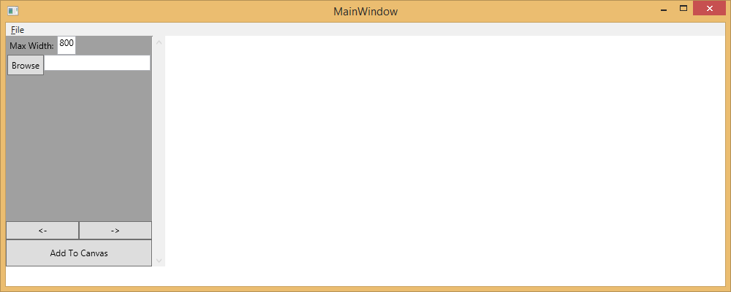 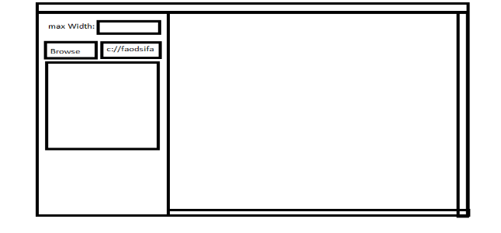

The intention of this UI was to have everything out for the user to see. We didn’t want there to be functionality hidden behind menus or pop ups. The only menu for this UI is file and it was clearly labeled menu items to help the user.

The first thing a user should do is decide how wide they want their sprite sheet to be. They will declare how wide, in pixels, they would like it to be. Once an image gets added to the canvas this cannot be changed.

* 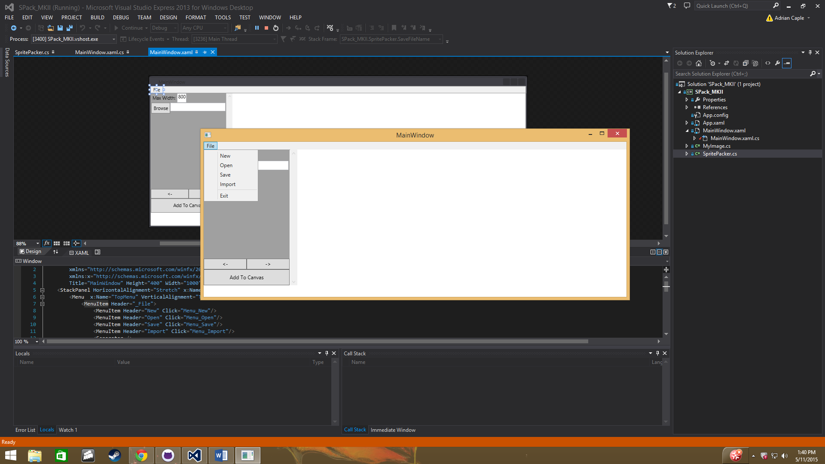New will create an empty canvas for the user to restart the sprite sheet
* Open will bring windows open dialog and allow the user to open one or more images and load them to the canvas
* Save will bring up windows save dialog and allow the user to name and save their sprite sheet to a specific location. It will also save an xml file to be used along with the image placed in the bin
* Import is similar to open, it is to be used after images have already been loaded to the canvas
* Exit properly closes the window using windows environment close



The user may also use browse to pick images to load onto the canvas, here they will see the file path of the last selected image. Before images are loaded onto the canvas they are put on the image preview below the Browse button. Here is where you can make sure you selected the right image and check for image quality before placing it onto the canvas. The left and right buttons are to preview multiple images if more than one image was selected. Once the user is satisfied with the selected images he/she can use Add to Canvas to place the selected images onto the canvas where it will be organized and placed as a sprite sheet.

XML Design Specification:

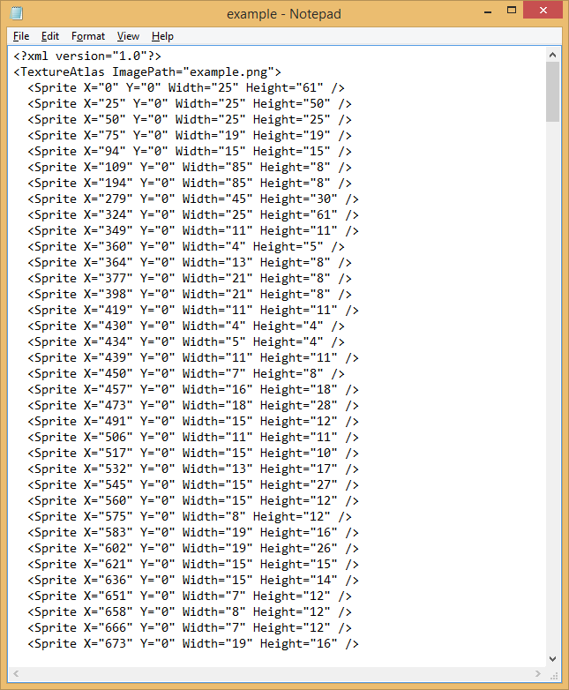

Here is how an XML file will be saved along with its PNG. The first thing the XML file will display is the XML declaration. The encoding is UTF-8 by default and is not stated. Next is the Atlas child which states the image name of the paired image to the XML. Once all that is printed, next comes all the child images. The images location is stated as x and y values by pixel. The width and height are also stated by pixel for the images.

UI Testing:

All tests were run manually. Starting with file’s submenu items:

* New wouldn’t reset Max Widths accessibility.
  + Set Max Widths accessibility after canvas was cleared
* Hitting new then cancel caused a crash
  + Now checks if file path is null; if it is, void function returns
* Open can’t open non image files
  + Exception handled for any unhandled file type
* Open wouldn’t preview non image files
  + Will now show an empty preview if selected file isn’t an image
* Open dialog hitting cancel causes crash
  + Now checks if file path is null; if it is, void function returns
* Left arrow button wouldn’t cycle through images correctly
  + Fixed logic to cycle through properly

User Guide:

The first thing you should do as a user is decide what the width of your sprite sheet will be. To set the width use the max width box on the upper left hand side of the window.



Next go to either file->Open or use the browse button to select the image(s) you would like to add to the sprite sheet. Be careful of the order in which you select your images. For now they cant be deleted or altered after they are added. This will be fixed in a later implementation.

Once you have added the images you would like to use go ahead and save your image using the

file->Save button. Once you picked where you would like to save your image and its name youll want to find the xml document that goes with it. You will need to open the executables folders for this. Go to the folder where you found SPack_MKII.exe. Here there will be a text file named the same as the image you saved. This is the XML file that goes with your sprite sheet. The Spritesheet itself is saved where you located it.